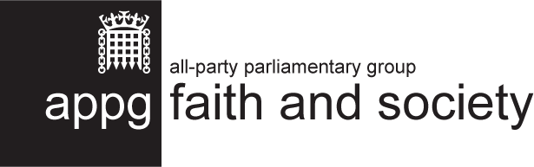
2022-23 Summary Report
April 2023

This is not an official publication of the House of Commons or the House of Lords. It has not been approved by either House or its committees. All-Party Parliamentary Groups are informal groups of Members of both Houses with a common interest in particular issues. The views expressed this report are those of the group.

Contents
Contents 2
Introduction 3
Key Activity in 2022-2023 4
#FaithinPartnership Week 2022 4
#FaithinCommunity Campaign 6
Faith Covenant Forum Meetings 7
The Faith Covenant: Update Report 9
Renewing the Faith Covenant 11
Future Plans 13
Appendix 14
The Faith Covenant: development and text 14

Introduction
The All-Party Parliamentary Group (APPG) exists to explore the role that faith plays in society, particularly through the work of faith-based organisations. It was formed after an initial idea by FaithAction in conversation with the Rt Hon Sir Stephen Timms MP.
The group held its inaugural meeting in January 2012 and has continued to receive support and interest from parliamentarians.
We are grateful to the group’s officers, who in 2022-23 were the following:
- Chair: Rt Hon Sir Stephen Timms MP
- Vice Chair: Sir Gary Streeter MP
- Vice Chair: Fiona Bruce MP
- Vice Chair: David Linden MP
- Vice Chair: Jon Cruddas MP
- Vice Chair: Baroness Neuberger
- Vice Chair: Lord Singh of Wimbledon
- Vice Chair: Baroness Uddin
- Secretary: David Lammy MP
We are pleased to be joined this year by Rt Rev Dame Sarah Mullally, The Lord Bishop of London as Vice Chair.
The aims of the group are:
- To promote understanding of faith-based organisations engaged in social action in the UK, and recognition of their value;
- To highlight the social, civic, and spiritual capital that faith-based organisations contribute to communities throughout the UK, and to identify and promote best practice among organisations;
- To consider regulatory and legislative arrangements which can make the most of the potential contribution of faith-based organisations;
- To learn from and contribute to international conversations, policy, and civic action on the contribution of faith-based organisations.
The APPG website is www.faithandsociety.org.

Key Activity in 2022-2023

#FaithinPartnership Week 2022
#FaithinPartnership week took place in September 2022. This was a week organised by FaithAction in collaboration with the APPG to celebrate and champion cross-sector partnerships between faith communities and statutory organisations. The week included a launch event for Keeping the Faith 2.0, the launch of the Faith Covenant Toolkit, and First In, Last Out, a report on how faith groups partnered with and supported the NHS during the pandemic.

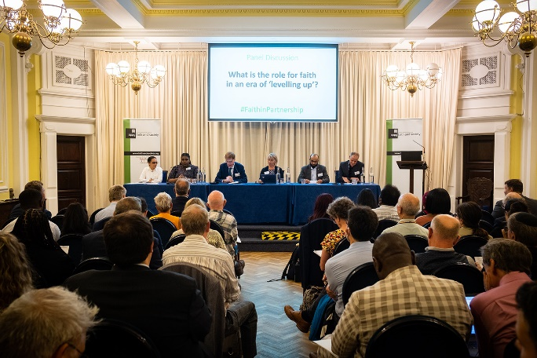
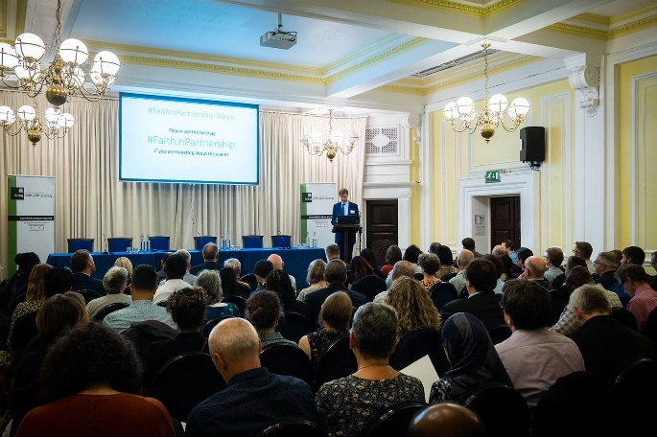
Keeping the Faith 2.0 report launch at Mary Sumner House, Wednesday 7th September
The launch of Keeping the Faith 2.0: Embedding a new normal for partnership working in post-pandemic Britain took place in September 2022, as a follow up report to Keeping the Faith: Partnerships between faith groups and local authorities during and beyond the pandemic, published in 2020. Keeping the Faith 2.0 looks at the extent to which COVID-19 has changed the nature of partnership working between faith groups and local authorities, and what this means for post-pandemic Britain.
Over 100 people attended the launch, which featured an exciting line-up of speakers including Paul Scully MP, the then Minister of State for Local Government, Faith and Communities, Sir Stephen Timms MP, report author Professor Chris Baker of Goldsmiths, University of London, and a panel of faith representatives:
- Dr Russell Rook, Good Faith Partnership
- Laura Marks, Mitzvah Day and Nisa Nashim
- Dr Jagbir Jhutti-Johal, University of Birmingham
- Shermara Fletcher, Churches Together in England
- Dr Omer Moghraby, British Islamic Medical Association.
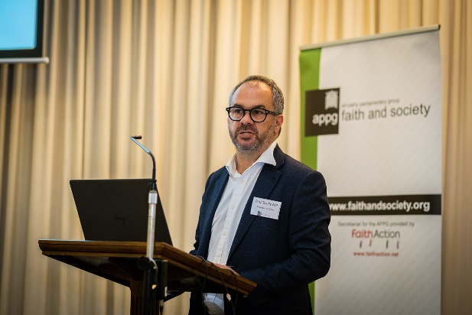
Paul Scully MP said “Faith forums are a powerful demonstration of what can be achieved when faith groups work hand in hand. They inform national guidance, promote public health messaging, and build and work together to create solutions” and that “Deep collaboration across sectors and faith groups is vital in the months ahead”. The panel discussion included the early preparedness of faith groups to support people during winter, the importance of the voices of women in discussions, the need for faith groups to be trusted, the importance of tailoring health services to get better outcomes, and the need for all local authorities to have open discussions with faith groups.
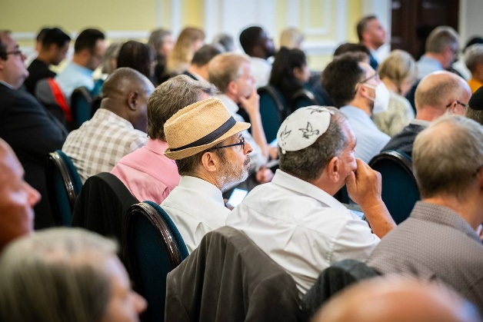
Attendees also raised various issues during the Q&A session, including the role of faith groups in social prescribing, how to support faith groups in their community work, religious literacy and increasing dialogue with the private sector. We received excellent feedback from attendees at the launch.
We were delighted with the level of engagement with the launch of this report, as well as #FaithinPartnership more broadly, and are planning to build upon its success this coming year.
The Faith Covenant Toolkit: What, Why, How?
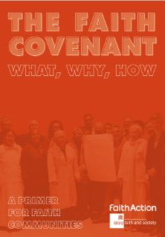
As per our planned work for 2022, FaithAction and the APPG developed and launched the Faith Covenant Toolkit, which is designed to be a primer for anyone (whether in a local authority or a faith organisation) interested in the Faith Covenant. It contains case studies from a number Covenant areas, with top tips, core principles, and first steps on the journey to signing. The document was officially launched online during #FaithinPartnership Week.

First in, Last Out
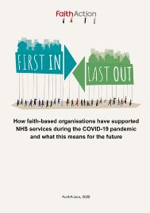
First in, Last Out looks specifically at how faith groups supported and partnered with NHS services during the pandemic, and what this means for the future of health and care partnerships.
FaithAction were asked by NHS England to research and report on the role played by faith-based organisations during the pandemic, and how this might be built upon as Integrated Care Systems develop strategies for engagement.
Surveys, roundtables, and interviews revealed a huge amount of encouraging partnership work that had happened; demonstrating that these activities can form the foundation for a new way of operating for local health and care systems, where faith groups are valued and trusted and are a strategic part of planning for integrated care.
The report was launched online during #FaithinPartnership week.

#FaithinCommunity Campaign
The #FaithinCommunity campaign looks to capture good stories of the work of faith groups during the COVID-19 pandemic and create a permanent record for future generations. It is a collaboration across different faiths and community groups.
The campaign was created by Spurgeon’s College, a Baptist training College in South East London. Spurgeon’s held a meeting with Sir Stephen Timms MP, on behalf of the APPG, and members of the FaithAction team. The APPG provided its endorsement for the campaign, and FaithAction supported this through a promotional interview with Reverend Helen Stockley about the importance of the campaign, touching on many issues such as the indispensable role for faith groups in society, the willingness of grassroots communities to roll up their sleeves and dig in during difficult times, and the future for partnership work between faith and government.

Faith Covenant Forum Meetings
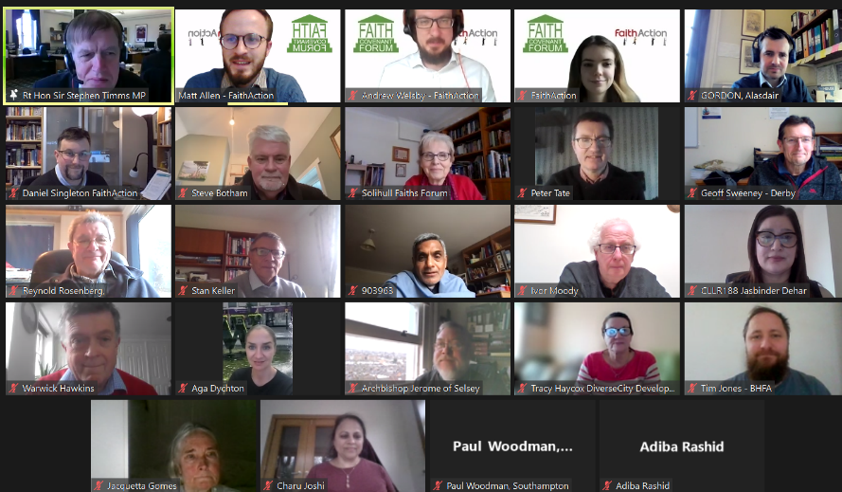
Faith Covenant Forum meetings bring together council and faith representatives from across the Faith Covenant areas to share ideas best practice. It has also proved to be a valuable opportunity for prospective or interested local authority areas to attend and gain insight as to what signing a Covenant might involve.
The meetings are online, and chaired by Rt Hon Sir Stephen Timms MP and Daniel Singleton, National Executive Director of FaithAction
July 2022
The fifth meeting of the Faith Covenant Forum took place on 14thJuly 2022.
- It was attended by 35 individuals and 8 Covenant areas were represented, with an additional 7 prospective areas.
- Baroness Uddin spoke on faith hate, on her own experience of faith hate, and highlighted that good work was happening in local places, despite the issue persisting.
- Attendees discussed different approaches to tackle faith hate in their own areas, the issues of under reporting of hate crimes, and tracking community tensions.
- Esmond Rosen, Chair of Brent Multi Faith Group and Reverend Alan Green, Chair of Tower Hamlets Inter Faith Forum spoke on changes in the local councils after the local elections held in May 2022, and the importance of maintaining good relationships with councillors from both political sides.

November 2022
- The sixth meeting of the Faith Covenant Forum took place on 10th November 2022.
- Professor Chris Baker reflected on the successful launch event for keeping the Faith 2.0, and spoke on the powerful findings of the report, such as shared values, the importance of co-creation and the need for kenotic leadership.
- Andrea King and Claudia Coussins from the Anna Freud National Centre for Children and Families presented on the new Family Hubs scheme and informed attendees of what family hubs are and the role they can play in supporting families with a range of services all in one place.
- The team were keen to engage on how the Faith Covenant can reference Family hub development.
- Attendees took part in a Q&A session,
- Various Faith Covenant areas updated on local developments

March 2023
- The seventh meeting of the Forum took place on 9th March 2023.
- It was attended by 36 individuals and 8 Covenant areas were represented, with an additional 3 prospective areas.
- Southampton and Calderdale presented an update on activity in their local areas, including food distribution networks funded by a Faith New Deal grant, and a re-signing of the covenant in both areas, with further updates given by other areas around current priorities and challenges.
- Esther Platt from Good Faith Partnership gave an overview of the Warm Spaces programme. Discussion included the importance of being consistent, evaluating the impact of the support, and that a long-term solution is necessary.

The Faith Covenant: Update Report
The roll-out of the Faith Covenant continues to be a focus for the APPG’s public work. The Covenant emerged from a series of roundtable meetings held by the APPG in 2012 to explore the work of faith-based organisations. It is a joint commitment between faith communities and local authorities to a set of principles that guide engagement, aiming to remove some of the mistrust that exists and to promote open, practical working on all levels. It is built on the recognition that, in order to meet the challenges the country faces, we need to unlock the potential of every part of civil society to contribute – including faith groups.
For further information on the development of the Faith Covenant, and its text, see the Appendix.

Covenant areas
The Covenant has been signed in 24 local areas, meaning that over 5 million people live in areas that have adopted it.

- Birmingham
- Leeds
- Barnet
- Solihull
- Calderdale
- Southampton
- Blackpool
- Essex (county wide)
- Basildon
- Braintree
- Chelmsford
- Colchester
- Maldon
- Rochford
- Brentwood
- Uttlesford
- Castle Point
- Harlow
- Epping Forest
- Brent
- Wolverhampton
- Preston
- Brighton and Hove
- Coventry

FaithAction continues to offer advice and support to faith groups and/or councils in areas that are considering adopting the Covenant, as well as connecting them with existing Covenant areas in order to share learning. Other areas that are currently exploring adopting the Covenant include:

- Bradford
- Hertfordshire (county wide)
- Greater London Authority
- Luton
- Rotherham
- Thurrock
- Watford
- Cornwall
- Westmoreland and Furness
- Tower Hamlets
- West Yorkshire
- Kirklees
- Barking & Dagenham
- Sheffield
- Buckinghamshire
- Warwick
- Leicester
- Redbridge
- Southend
- North Lincolnshire

Other Faith Covenant Developments
- West Midlands Combined Authority have committed to signing the Faith Covenant and South Yorkshire Mayoral Combined Authority have approached FaithAction to investigate signing the Faith Covenant.

Supporting Faith Covenant Adoption
National Executive Director at FaithAction, Daniel Singleton, visited Coventry during Inter Faith Week 2022 to discuss the Faith Covenant with local faith representatives.
This led to Coventry becoming the 25th area to sign the Faith Covenant in March 2023, at an event attended by FaithAction, local council representatives and faith leaders.
The Covenant was signed in a meeting chaired by Deputy Leader Councillor Abdul Salam Khan, as part of ongoing work which began over a year ago.
Cllr Khan said: “Coventry is a very special place and that’s because it has always had positive relations between different communities and faith groups.
“We have signed up to this Faith Partnership to recognise the good work already being achieved. I hope we can promote it more widely so that more local faith groups sign up.”
The next steps for Coventry will involve introducing the Faith Covenant to elected members and Officers and to encourage wider sign-up from Coventry faith groups.

Renewing the Faith Covenant

Birmingham, November 2022
Birmingham renewed their Faith Covenant, during an event in Inter Faith Week 2022. The Covenant was formally signed by Cllr John Cotton, Cabinet Member for Social Justice, Community Safety and Equalities and the city’s faith leaders.
Sir Stephen Timms MP, Chair of the APPG, and Daniel Singleton of FaithAction also took part in the signing at the Council House.
The council has remained fully committed to the Covenant since its launch, but Cllr Cotton wanted to formally note his support for its principles and reaffirm the council’s commitment to working with partners to deliver refreshed pledges.
Cllr Cotton said: “Birmingham's many faith communities play a vital role: wherever you go in our city you will find people of faith at the forefront of the efforts to tackle poverty, hardship and inequality.
“We saw this most vividly during the pandemic, as communities came together to help each other and reach out to those in need. Yet again, Birmingham showed how to be a welcoming city where people from different communities support one another as neighbours and friends.
“The Faith Covenant’s principles have been refreshed to reflect the vital role faith communities have across the city, to bring people together, support one another, particularly the most vulnerable in our society.
“By working together, we can deliver so much more for the people of Birmingham. I'm proud to join with our faith communities today as we renew and restate our partnership through this Faith Covenant."
Dr Peter Rookes, Secretary of Birmingham Council of Faiths, added: “It is very appropriate that we should be signing this Faith Covenant at the start of Inter Faith Week, coordinated by Birmingham Council of Faiths, during which Birmingham has 25 events taking place between people of different faiths and with people of no faith.
“Our faith organisations are thankful for our close relationship with the city council, and proud of being the first city in 2014, of signing a faith covenant.”

Southampton, November 2022
Southampton renewed their Faith Covenant in November 2022, during an event at the Lord Mayor’s Parlour, attended by leaders from faith communities and Southampton City Council. The covenant was first signed over five years ago, on 2nd July 2017.
Chair of the Southampton Council of Faiths, David Vane said: “The APPG on Faith and Society is convinced that faith groups have a great deal to offer as providers and advocates for the communities in which they serve, and that some of their potential is being unnecessarily overlooked at present. To help tackle the problem, the national group drafted a Covenant which can be adopted by faith groups and local authorities in cities across the UK. We were delighted to recommit ourselves to the Faith Covenant today.”
Bishop of Southampton, Rt Rev Debbie Sellin spoke at the relaunch event and praised those signing the covenant, saying “There has been genuine partnership at the heart of the work in Southampton, particularly during the pandemic, when people in Southampton from across different backgrounds have worked incredibly well together to bring hope to others and work for the common good of the city.”
The event was part of a grant programme, the Faith New Deal, funded by the Department for Levelling Up, Housing and Communities. Speaking at the event, Daniel Singleton, National Executive Director of FaithAction, commented: “The coming decade will see the country facing new social needs and tough new challenges. There will be fresh demands on public health, social care, education, employment support and community inclusion. These challenges will require the identification of a new set of resources. We will need to unlock the potential of every part of our society to contribute towards solutions. We believe that one important resource can be realised by supporting faith-based organisations to work with local authorities constructively and effectively, as part of civil society.”

Future Plans
We have been greatly encouraged by the interest shown in the Faith Covenant by several local authorities this year and will continue to work closely with them to encourage its official adoption in the near future.
Current future plans include:
- #FaithinPartnership Week 2023—Building on the success of last September’s #FaithinPartnership week, we want to continue to provide a forum for public discussion this year around the vital partnership role for faith-based organisations in the support of their local communities. We will revive the #FaithinPartnership hashtag this September and hold events/discussions (both online and in person) in line with this theme. Examples of what this may include are:
  - Bringing Faith Covenant areas together for an in-person ‘Faith Covenant Forum Live’
  - A launch/discussion around a Faith Covenant for Health.
  - A discussion about the Faith Commissioner role recommended in the Keeping the Faith reports.
- Faith New Deal Programme—The Government’s Faith New Deal Pilot Scheme (funded by DLUHC) has recently come to a close. We would like to host an event featuring several pilot projects (including Southampton) to share the learning and discuss recommendations for future iterations of the scheme as well as the proposed national Faith Compact.
- Health Inequalities—We would like to convene meetings exploring the increasing role faith and belief groups might play in addressing health inequalities, and integrating with local health and care systems. This may include promotion of existing research and publications on such topics as social prescribing, inequalities in pregnancy and maternity.
- Faith and Society roundtables—We would like to convene a series of 3-4 roundtables on challenging policy issues where the role of faith groups might provide a new way through – for example, addressing health disparities; improving immigration and integration strategies; and the levelling up agenda.
- 2021 Census results roundtable—The 2021 Census found that for the first time, fewer than 50% of respondents listed their religious identity as ‘Christian’. We propose convening another roundtable to discuss what the lessons behind the numbers are and their political and social implications.

Appendix

The Faith Covenant: development and text

Background
The Covenant emerged from a series of roundtable meetings held by the APPG in 2012 to explore the work of faith-based organisations. These focused on the areas of welfare to work, children and young people, and health and wellbeing, as well as the work of faith groups internationally.
A common theme emerging from these discussions was a concern about the relationship between faith-based organisations and local authorities. On the one hand, local authorities and grant-making bodies can be uneasy about faith playing a part in service delivery. As a consequence, faith-based organisations often feel compelled to downplay the role and importance of faith in their work, although to them it plays a central part – resulting in a lack of integrity. On the other hand, religious illiteracy among local authorities means there is a difficulty in understanding what faith-based organisations are about and how best to relate to them.
During the 2013 Annual General Meeting of the APPG, the Rt Hon David Lammy MP suggested that faith groups might be able to encourage local authorities to sign up to a charter setting out an agreement for how the two would relate to each other.
This led to the development by the APPG of the Covenant for engagement between local authorities and faith groups. Professor Francis Davis also played a key part in drafting the text of the Covenant.
The full text of the Covenant can be found below. The Covenant is a joint commitment between faith communities and local authorities to a set of principles that guide engagement, aiming to remove some of the mistrust that exists and to promote open, practical working on all levels.

Covenant text
The coming decade will see the country facing new social needs and tough new challenges. There will be fresh demands on public health, social care, education, employment support and community inclusion. These challenges will require the identification of a new set of resources. We will need to unlock the potential of every part of our society to contribute together towards solutions.
We believe that one important resource can be realised by supporting faith-based
organisations to work constructively and effectively, as part of civil society, with local authorities. That will mean ensuring that local authorities are confident in commissioning services from and transferring assets to appropriately qualified faith-based organisations, and that they include faith groups when they look for solutions to social needs.
The APPG on Faith and Society is convinced that faith groups have a great deal to offer as providers and advocates for the communities in which they serve, and that some of their potential is being unnecessarily overlooked at present. To help tackle the problem, the Group has drafted a Covenant which can be adopted by faith groups and local authorities in cities across the UK.
The Covenant principles are currently in draft form, and in some cases have been adapted to suit local circumstances. Local authorities that are interested in adopting the Covenant should contact FaithAction.

The Covenant
The Covenant is a joint commitment between faith communities and local authorities to a set of principles that guide engagement, aiming to remove some of the mistrust that exists and to promote open, practical working on all levels.
Together, local authorities and faith communities should work out a local version of the commitments below, according to the priorities and needs of that locality.
The Covenant is built on the following principles:
- Faith communities are free to practise their beliefs and religious observances without restriction, and to raise their voice in public debate and to be respected, within the framework of UK law.
- Public services and faith based social action should respect service users from all backgrounds, with no discrimination on the grounds of religion, gender, marital status, race, ethnic origin, age, sexual orientation, mental capability, or long-term condition.
- The voice, participation, and solutions that faith communities bring are important, and consultation should enable them to be brought to bear for the benefit of the wider community.
- Organisations and services are stronger for drawing on diverse sources of funding; monopolies of funding, action and participation are damaging.
The Covenant entails the following commitments: Local authorities commit to welcome the involvement of faith groups in the delivery of services and social action on an equal basis with other groups. In addition, they commit to:
- Building relationships and trust with faith groups;
- Adopting strategies for the engagement of faith communities in consultation exercises;
- Encouraging faith groups and their members to be involved in the reshaping and redesign of local services;
- Establishing clear guidelines around funding;
- Sharing training and learning opportunities between faith communities and the local authority.
Faith-based organisations commit to work actively with local authorities in the design and delivery of services to the public. In addition, they commit to:
- Seeking opportunities to bring people together to serve the community, particularly its poorest and most isolated members;
- Serving equally all local residents seeking to access the public services they offer, irrespective of their religion, gender, marital status, race, ethnic origin, age, sexual orientation, mental capability, or long-term condition;
- Using resources provided for delivering a service wholly for that purpose, and not for any other;
- Ensuring excellence in child protection, health and safety, accountability and transparency;
- Responding to consultations where appropriate;
- Sharing training and learning opportunities between faith communities and the local authority.


FaithAction, secretariat to the All-Party Parliamentary Group of Faith and Society, is a national network of faith-based and community organisations and a member of the VCSE Health and Wellbeing Alliance, working with the Department of Health and Social Care, NHS England, and Public Health England. FaithAction works to provide support, advice, and training for its members, as well as partnering with local and central governments to highlight the contributions made by these organisations to their communities.
www.faithaction.net
LifeLine House, Neville Road, Dagenham, RM8 3QS
0800 804 8829 • info@faithaction.net

