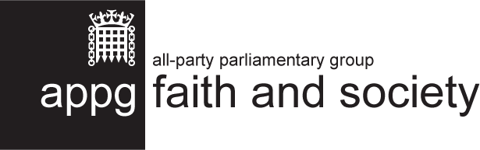
2024-25 Summary Report
March 2025

This is not an official publication of the House of Commons or the House of Lords. It has not been approved by either House or its committees. All-Party Parliamentary Groups are informal groups of Members of both Houses with a common interest in particular issues. The views expressed in this report are those of the group.

Contents
Contents 2
Introduction 3
Key Activity in 2024-2025 4
Faith New Deal Event 4
#FaithinPartnership Week 2024 4
The Faith Covenant: Update Report 6
New Signings of The Faith Covenant 7
Renewing the Faith Covenant 10
Future Plans 10
Appendix 11
The Faith Covenant: development and text 11

Introduction
The All-Party Parliamentary Group (APPG) exists to explore the role that faith plays in society, particularly through the work of faith-based organisations. It was formed after an initial idea by FaithAction in conversation with the Rt Hon Sir Stephen Timms MP.
The group held its inaugural meeting in January 2012 and has continued to receive support and interest from parliamentarians.
The most recent AGM was held in February 2024. When UK Parliament was dissolved at the end on May 2024 the APPG ceased to officially exist from this point.
We are grateful to the group’s officers, who in 2023-24 were the following:

- Chair: Rt Hon Sir Stephen Timms MP
- Vice Chair: Sir Gary Streeter MP
- Vice Chair: David Linden MP
- Vice Chair: Jon Cruddas MP
- Vice Chair: Baroness Neuberger
- Vice Chair: Lord Singh of Wimbledon
- Vice Chair: Baroness Uddin
- Vice Chair: Rt Rev Dame Sarah Mullally, The Lord Bishop of London
- Vice Chair Afzal Khan MP
- Vice Chair Tanmanjeet Singh Dhesi MP
- Secretary: David Lammy MP

The aims of the group are:
- To promote understanding of faith-based organisations engaged in social action in the UK, and recognition of their value;
- To highlight the social, civic, and spiritual capital that faith-based organisations contribute to communities throughout the UK, and to identify and promote best practice among organisations;
- To consider regulatory and legislative arrangements which can make the most of the potential contribution of faith-based organisations;
- To learn from and contribute to international conversations, policy, and civic action on the contribution of faith-based organisations.
The APPG website is www.faithandsociety.org.

Key Activity in 2024-2025
Due to the election, less activity occurred than usual. However, some activity still took place.
Faith New Deal Event
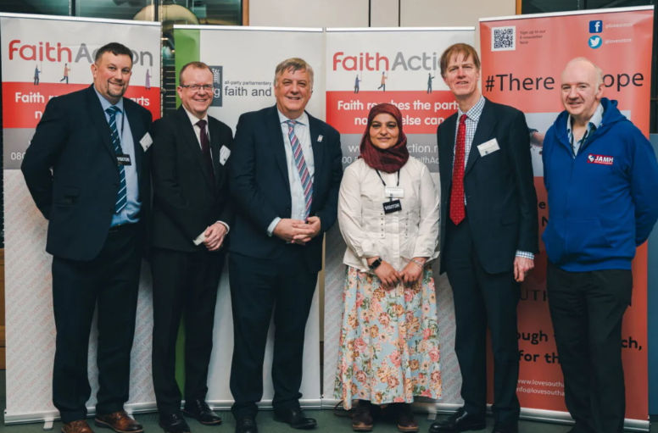
The event, Faith New Deal Pilot Fund Spotlight on: Love Southampton, took place on 26th February 2024 at Portcullis House, after being postponed due to the prorogation of parliament in October 2023. It featured a variety of perspectives on this impressive, cross-sector collaboration and how national and local government can continue to partner effectively with faith groups to support the most marginalised in our society. With host Rt Hon Sir Stephen Timms MP, Baroness Scott of Bybrook (faith minister at the time) and panellists from Love Southampton, Faith & Belief Forum and Jewish Action for Mental Health, attendees had the opportunity to put questions to the panel and take part in a networking session with refreshments.

#FaithinPartnership Week 2024
#FaithinPartnership week took place in September 2024. This campaign was conceived and set up through the APPG in 2022 and was a core part of the APPG workplan for 2024 prior to the general election. FaithAction facilitated the week to celebrate and champion cross-sector partnerships between faith communities and statutory organisations.
Part of the aim of the week is to encourage more areas to sign the Faith Covenant. The week consisted of a series of in-person and online events to bring together faith groups, statutory body representatives, local authority representatives, parliamentarians and others to highlight some of the fantastic work being done as part of this collaboration.
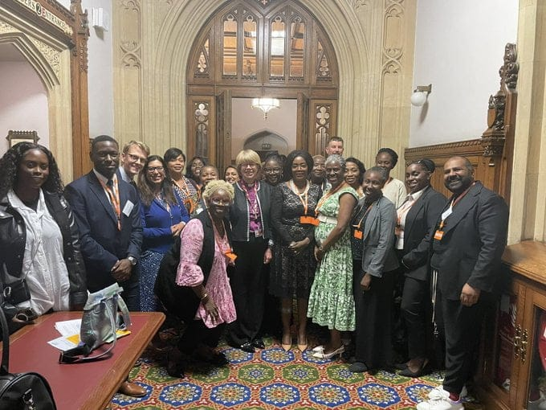
On Monday, 9th September 2024, a panel discussion titled Faith for a Safe Start explored how faith communities can collaborate with the NHS and other stakeholders to reduce maternal health inequalities for black and minority ethnic women. Chaired by the Bishop of London, Dame Sarah Mullally, the event featured contributions from national leaders, including Wendy Olayiwola, National Maternity Lead for Equality at NHS England, as well as insights from individuals with lived experience and grassroots initiatives tackling these disparities.
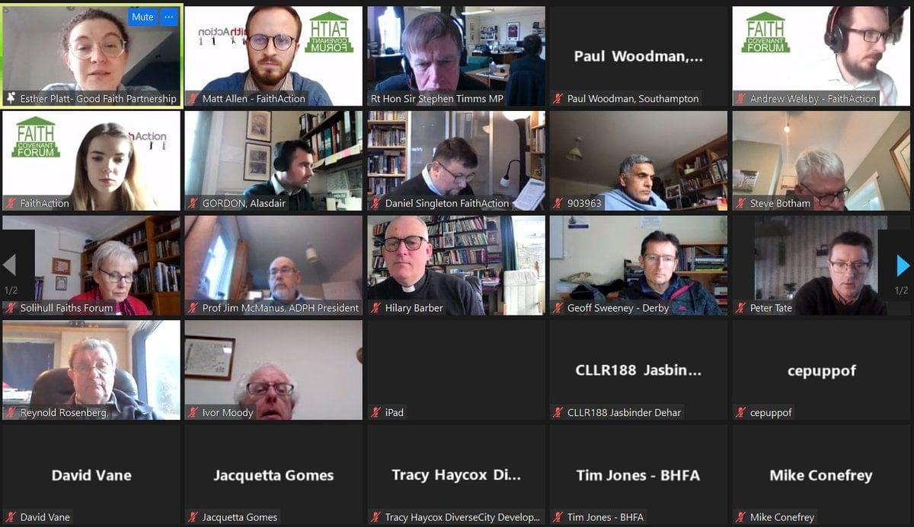
On Tuesday, 10th September 2024, the Faith Covenant Forum marked the 10th anniversary of the first Faith Covenant signed by Birmingham City Council. Representatives from Faith Covenant areas, along with those considering signing, joined the discussion. The forum explored the findings of FaithAction’s What Matters to Us survey, conducted during the election campaign to understand faith communities' priorities for the new government. Attendees also reflected on the successes of the past decade and shared their aspirations for the future of their Covenants.
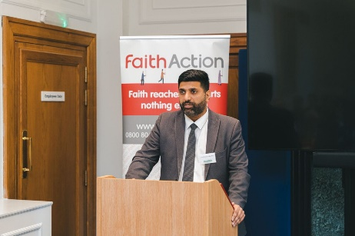
On Wednesday, 11th September 2024, a Faith for the Future breakfast reception celebrated Faith in Partnership and 10 years of the Faith Covenant. Featuring Lord Khan, Minister for Faith, the event highlighted the success of partnership working in Covenant areas and explored how collaboration between faith groups and statutory bodies can leverage the trust faith communities have built within their local areas.
We were very pleased with the level of engagement in #FaithinPartnership this year; we are currently planning for the fourth #FaithinPartnership week that will take place this September.

The Faith Covenant Toolkit: What, Why, How?
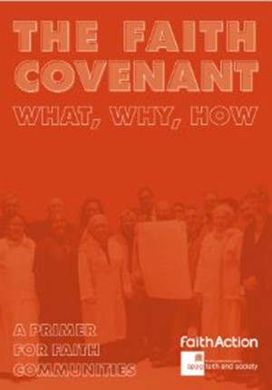
The Faith Covenant Toolkit continues to be utilised by faith groups and local authorities, over 300 copies have been downloaded since its launch in September 2022. The toolkit is designed to be a primer for anyone (whether in a local authority or a faith organisation) interested in the Faith Covenant. It contains case studies from a number Covenant areas, with top tips, core principles, and first steps on the journey to signing.

The Faith Covenant: Update Report
The roll-out of the Faith Covenant continues to be a focus for the APPG’s public work. The Covenant emerged from a series of roundtable meetings held by the APPG in 2012 to explore the work of faith-based organisations. It is a joint commitment between faith communities and local authorities to a set of principles that guide engagement, aiming to remove some of the mistrust that exists and to promote open, practical working on all levels. It is built on the recognition that, in order to meet the challenges the country faces, we need to unlock the potential of every part of civil society to contribute – including faith groups.
For further information on the development of the Faith Covenant, and its text, see the Appendix.

Covenant areas
The Covenant has been signed in 33 local areas, meaning that over 12 million people live in areas that have adopted it.

Birmingham
Leeds
Northamptonshire
Barnet
Solihull
Calderdale
Southampton
Blackpool
Essex
Basildon
Braintree
Chelmsford
Colchester
Maldon
Rochford
Brentwood
Uttlesford
Castle Point
Harlow
Epping Forest
Brent
Wolverhampton
Preston
Brighton and Hove
Coventry
West Midlands Combined Authority
Sandwell
Walsall
Dundee
Welwyn Hatfield
Hertfordshire
Cornwall
Greater Manchester Combined Authority

New Signings of The Faith Covenant
Cornwall signed the Faith Covenant on 13th November 2024, during Interfaith Week, and faith groups from across Cornwall came together at to mark the occasion..
Members of the Baha’i, Buddhist, Christian, Hindu, Islam, Jewish, and Pagan faiths, alongside a representative from the Humanist community signed the Covenant document on behalf of their communities. The Covenant was also signed by Cllr Linda Taylor, Leader of Cornwall Council and Kate Kennally, Chief Executive on behalf of Cornwall Council and Andrew Yates (Chair) on behalf of Cornwall Faith Forum.
The council are commitment to working with faith-based organisations to explore the development of a Faith Covenant for Cornwall was an important element of our 2022-2026 Equality, Diversity and Inclusion Strategy.
Cornwall Council is the first local authority in the south-west and the first wholly rural authority to develop a Covenant. The Faith Covenant Working Group worked hard to:
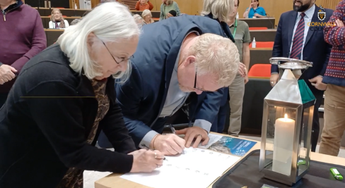
- Develop a Covenant based on shared values that promotes community cohesion and celebrates the diversity of Cornwall.
- Reference the Cornwall Faith Forum key themes and Cornwall Council’s Business Plan objectives.

- Ensure that the Covenant delivers concrete, measurable results.
- Identify initial work areas, including a faith literacy programme and social action mapping of faith community initiatives.
- Actively engage with faith communities, Cornwall Council services, and other stakeholders, including through consultations and surveys (e.g., Let’s Talk Cornwall).
- Consider and incorporate all feedback received.
We look forward to seeing how the Covenant progresses in Cornwall.

Regional leaders and Faith and Belief community representatives signed the Greater Manchester Faith, Belief and Interfaith Covenant during Inter Faith Week 2025.
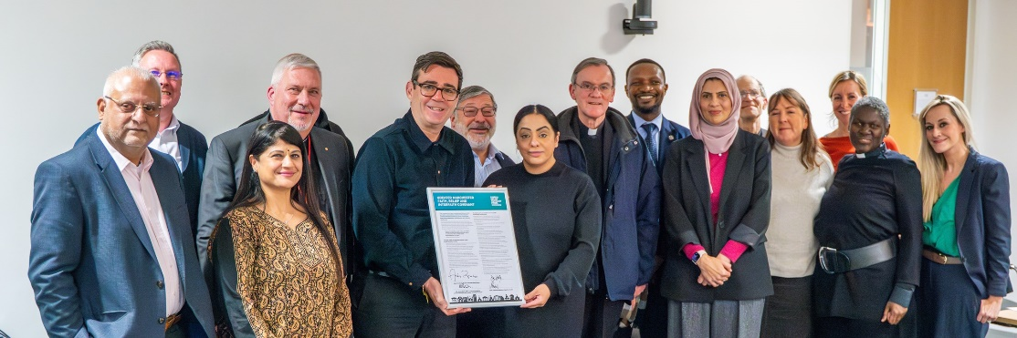
Mayor of Greater Manchester, Andy Burnham, was joined by Councillor Arooj Shah, GMCA Portfolio Lead for Equalities and Communities, and co-chairs of the Greater Manchester Faith and Advisory Panel to sign the Covenant which is built on the principles of engagement, collaboration and delivery.
Mayor of Greater Manchester, Andy Burnham, said:
"Today’s Faith, Belief and Interfaith Covenant signing recognises the invaluable contribution that our diverse Faith and Belief communities make across our city-region. Greater Manchester prides itself on the cohesion between our different communities - we’re our strongest when we work together.
“The commitment we signed today is not just words on a page but outlines how we plan to go forward. Greater Manchester is a place where everyone belongs; there is no room for discrimination anywhere. The joint signing sends the clearest of messages throughout our ten boroughs that this is what our city-region is about."
Manjari Patel and Revd. Ian Rutherford, GM Faith and Belief Advisory Panel Co-chairs, said:
“This Covenant is not just a document; it is a living commitment to trust, transparency, shared values, and innovative thinking. It underpins the panels work to support communities in Greater Manchester, help make a difference and act on poverty, homelessness, digital inclusion, climate change and social justice.”
We look forward to seeing the impact of the Faith Covenant in Greater Manchester as time progresses.

Other Faith Covenant Activities
Faith Covenant Forums
Faith Covenant Forum meetings bring together council and faith representatives from across the Faith Covenant areas to share ideas best practice. It has also proved to be a valuable opportunity for prospective or interested local authority areas to attend and gain insight as to what signing a Covenant might involve.
The meetings are online and were chaired by Rt Hon Sir Stephen Timms MP and Daniel Singleton, National Executive Director of FaithAction.
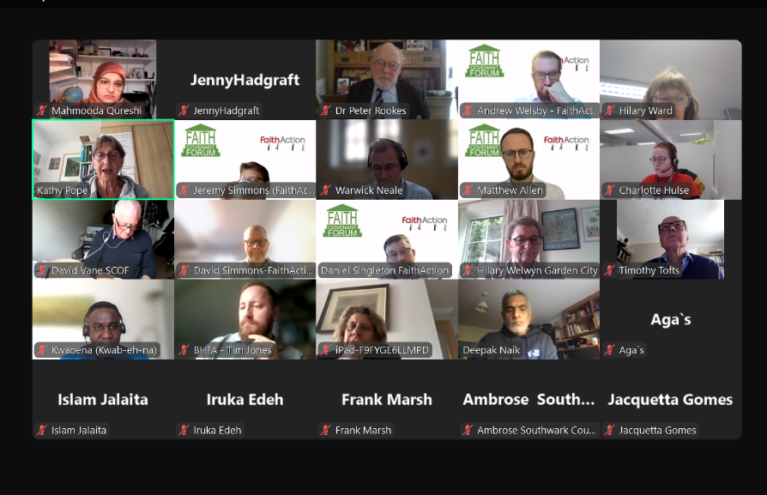
The ninth meeting of the Faith Covenant Forum took place on 24th July 2024.
- Discussion included priorities around faith for the new government, covering a number of areas including health, climate change and unemployment.
- Wording of the Covenant around proselytization was discussed by attendees.
- Representatives from areas around the country shared their work around community tensions, including having honest conversations and highlighting shared values.
The tenth meeting of the Faith Covenant Forum took place on 10th September 2024.
- FaithAction presented a summary of findings from their survey that focused on what matters to people of faith and what they want a new government to focus on. The discussion that followed included ideas around more collaboration between health services and the faith sector, and more funding for education.
- Further discussion included the tensions in the Middle East and the riots.

Future Faith Covenant Areas
FaithAction continues to offer advice and support to faith groups and/or councils in areas that are considering adopting the Covenant, as well as connecting them with existing Covenant areas in order to share learning.
Other areas that are currently exploring adopting the Covenant include:
Watford, Hampshire & Isle of Wight ICB (encompassing all of Hampshire statutory services) and London Borough of Camden.

Renewing the Faith Covenant
Brent Multi Faith Forum re signed the Faith Covenant during Inter Faith Week 2024 at an event in parliament hosted by Dawn Butler MP. The occasion also featured the launch of the Brent Youth Faith Alliance.

Future Plans
We have been greatly encouraged by the latest signings of the Faith Covenant, and the interest shown in the Faith Covenant this year and will continue to work closely with these areas to encourage its official adoption in the near future.
Current potential areas of work for the year ahead are:
- Faith in Partnership Week 2025. Faith in Partnership Week celebrates collaboration between faith groups and statutory bodies in the UK to drive positive change for vulnerable communities. This week of activity will potentially include:
- Faith covenant launches, new areas that sign during this week
- Faith covenant forum, online discussion sharing best practice
- Faith for a Safe Start launch, a toolkit aimed at faith leaders, empowering them to be part of tackling maternal inequalities.
- A roundtable on faith and social care, in relation to the Casey review into investment and reforms to improve adult social care.
- Faith Literacy: Potentially looking at faith at work, ICB Covenants and the Civil Society Covenant
- Approaches by researchers: The APPG is often approached by academics involved in or proposing new research, who would like to present their work.

Appendix

The Faith Covenant: development and text

Background
The Covenant emerged from a series of roundtable meetings held by the APPG in 2012 to explore the work of faith-based organisations. These focused on the areas of welfare to work, children and young people, and health and wellbeing, as well as the work of faith groups internationally.
A common theme emerging from these discussions was a concern about the relationship between faith-based organisations and local authorities. On the one hand, local authorities and grant-making bodies can be uneasy about faith playing a part in service delivery. As a consequence, faith-based organisations often feel compelled to downplay the role and importance of faith in their work, although to them it plays a central part – resulting in a lack of integrity. On the other hand, religious illiteracy among local authorities means there is a difficulty in understanding what faith-based organisations are about and how best to relate to them.
During the 2013 Annual General Meeting of the APPG, the Rt Hon David Lammy MP suggested that faith groups might be able to encourage local authorities to sign up to a charter setting out an agreement for how the two would relate to each other.
This led to the development by the APPG of the Covenant for engagement between local authorities and faith groups. Professor Francis Davis also played a key part in drafting the text of the Covenant.
The full text of the Covenant can be found below. The Covenant is a joint commitment between faith communities and local authorities to a set of principles that guide engagement, aiming to remove some of the mistrust that exists and to promote open, practical working on all levels.

Covenant text
The coming decade will see the country facing new social needs and tough new challenges. There will be fresh demands on public health, social care, education, employment support and community inclusion. These challenges will require the identification of a new set of resources. We will need to unlock the potential of every part of our society to contribute together towards solutions.
We believe that one important resource can be realised by supporting faith-based
organisations to work constructively and effectively, as part of civil society, with local authorities. That will mean ensuring that local authorities are confident in commissioning services from and transferring assets to appropriately qualified faith-based organisations, and that they include faith groups when they look for solutions to social needs.
The APPG on Faith and Society is convinced that faith groups have a great deal to offer as providers and advocates for the communities in which they serve, and that some of their potential is being unnecessarily overlooked at present. To help tackle the problem, the Group has drafted a Covenant which can be adopted by faith groups and local authorities in cities across the UK.
The Covenant principles are currently in draft form, and in some cases have been adapted to suit local circumstances. Local authorities that are interested in adopting the Covenant should contact FaithAction.

The Covenant
The Covenant is a joint commitment between faith communities and local authorities to a set of principles that guide engagement, aiming to remove some of the mistrust that exists and to promote open, practical working on all levels.
Together, local authorities and faith communities should work out a local version of the commitments below, according to the priorities and needs of that locality.
The Covenant is built on the following principles:
- Faith communities are free to practise their beliefs and religious observances without restriction, and to raise their voice in public debate and to be respected, within the framework of UK law.
- Public services and faith based social action should respect service users from all backgrounds, with no discrimination on the grounds of religion, gender, marital status, race, ethnic origin, age, sexual orientation, mental capability, or long-term condition.
- The voice, participation, and solutions that faith communities bring are important, and consultation should enable them to be brought to bear for the benefit of the wider community.
- Organisations and services are stronger for drawing on diverse sources of funding; monopolies of funding, action and participation are damaging.
The Covenant entails the following commitments: Local authorities commit to welcome the involvement of faith groups in the delivery of services and social action on an equal basis with other groups. In addition, they commit to:
- Building relationships and trust with faith groups;
- Adopting strategies for the engagement of faith communities in consultation exercises;
- Encouraging faith groups and their members to be involved in the reshaping and redesign of local services;
- Establishing clear guidelines around funding;
- Sharing training and learning opportunities between faith communities and the local authority.
Faith-based organisations commit to work actively with local authorities in the design and delivery of services to the public. In addition, they commit to:
- Seeking opportunities to bring people together to serve the community, particularly its poorest and most isolated members;
- Serving equally all local residents seeking to access the public services they offer, irrespective of their religion, gender, marital status, race, ethnic origin, age, sexual orientation, mental capability, or long-term condition;
- Using resources provided for delivering a service wholly for that purpose, and not for any other;
- Ensuring excellence in child protection, health and safety, accountability and transparency;
- Responding to consultations where appropriate;
- Sharing training and learning opportunities between faith communities and the local authority.


FaithAction, secretariat to the All-Party Parliamentary Group on Faith and Society, is a national network of faith-based and community organisations and a member of the VCSE Health and Wellbeing Alliance, working with the Department of Health and Social Care, NHS England, and Public Health England. FaithAction works to provide support, advice, and training for its members, as well as partnering with local and central governments to highlight the contributions made by these organisations to their communities.
www.faithaction.net
LifeLine House, Neville Road, Dagenham, RM8 3QS
0800 804 8829 • info@faithaction.net

